MORNING WORSHIP SERVICE
Sept 27, 2015

Opening Song “The Family of God” 386

Opening Prayer/Announcements

Worship Hymns “Come, Now Is the Time to Worship”
“Down in My Heart”
“Are you Washed in the Blood” 136
“Without Him” 300
“Alleluia” 223

Offering/Offertory

Special Music

Message Bro. David Atwood
.
Invitation “Only Believe” 534

Closing Prayer

Evening Service at 6:00

Living Proof Live
March 4-5, 2016 (Fri & Sat)
Waco, TX: Extraco Event Center
Contact Patti Radford if you might be interested in attending

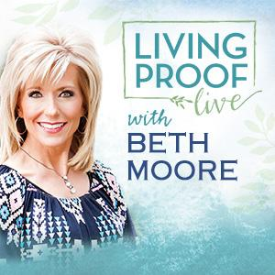
NURSERY – available for children age 0 to Kindergarten
Becky Yount

Hostesses for September Ushers for September
Cissy Atwood, Pam Daniel, Kenny Merrell, David Condron,
Mickey Stanford, Earline Burns Sam McManus, Mickey Stanford

Immediate Need Prayer List
Prayer & Request Information

(Please complete name & address information on reverse side)

I would like to speak with the Pastor.

I would like more information on this church.

I have Prayer Requests or Needs

Date:

Permission to Publicize:
Church Bulletin Yes No
Email Prayer Chain Yes No

Prayer Request:

Prayer For
Name
Address
Phone

Given By
Name
Address
Phone
Please Contact By

Card Phone Visit

Comments

Pray for Ann Skinner as she recovers from surgery

Pray Terri Edwards as she recovers from surgery

K s b c

Keeping His Word through Sunday School, Bible Study and Church Attendance/Worship

Sunday School Bible Studies for September:

Sept 6th God’s Promise of Faithfulness Psalm 89:1-2,5-8,15-18 Sept 13th God’s Promise of Eternal Life I John 5:6-13
Sept 20th God’s Promise of Provision Psalm 34:4-14
Sept 27th God’s Promise of Answered Prayer Luke 11:5-13

9:45 a.m. each Sunday – A place for everyone

WE’D LOVE FOR YOU TO JOIN US!

